


Korea Lunar Exploration Program
DTNPL Software Technical Description

Date: 28 Dec. 2017 | Doc. No: KPLO-D0-550-201  Issue: 1.0  Total page: 18

Superseding Revised

Prepared By:  Hyun-Woong Choi Date  DTN SBC S/W Engineer, Lumir  Dae-Soo Oh Date  DTN SBC Engineer, Lumir |  | Kyung-Rak Lee Date  DTN Payload Engineer, ETRI
Reviewed By:  Jin-Ho Jo Date  DTN System Engineer, ETRI |  | Sin-Ae Ji Date  Proximity-1 System Engineer, ETRI
Sang-Man Moon Date  RLE KPLO Electrical System, KARI |  | Hyun-Jin Shin Date  RLE KPLO Mechanical System, KARI
Approval Signature:  Byoung-Sun Lee Date  DTN Project Leader, ETRI |  | Il-Young Kim Date  RLE KPLO Product Assurance, KARI
Seong-Bin Lim Date  Head, Lunar Exploration System Team, KARI |  | Seok-Weon Choi Date  Director, Lunar Exploration Program Office, KARI

Original CDMO Release__________________

Revision History
Version | Author(s) |  | Date | Description
0.1 | Hyun-Woong Choi |  | 2017. 12. 28 | Draft

Revision/Change Records
Version | Date | Revision/Change Description | Pages
0.1 | 2017. 12. 28 | Initial | All

Documents Tree

Contents

1. Introduction 8
1.1. Purpose and Scope 8
1.2. Applicable Documents 8
1.2.1. ETRI Documents 8
1.2.2. Other Documents 8
1.3. Abbreviations 8
2. Overview of KPLO DTN 10
2.1. DTN and Space Communications 10
2.2. Mission of DTN Operation 10
2.3. DTN Configurations 10
2.4. Communication Nodes 11
2.4.1. DTN nodes 11
2.4.2. Non-DTN nodes 11
3. Operations and Maintenance Manual 12
4. Communication Protocols 13
4.1. TM/TC Protocols 13
4.1.1. UART Protocol 13
4.1.2. Packet Format 13
4.1.3. TM/TC Data Structure 14
4.2. Datalink Protocol 14
4.2.1. Datalink protocol for downlink 15
4.2.2. Datalink Data Structure 16
4.3. TM/TC Lists 16
4.3.1. Command Lists 16
4.3.2. Telemetry Lists 16

Figures

Figure 2.1 DTN test configuration in the first phase 11
Figure 3-1 Interface diagram of DTN payload 12
Figure 3-2 Electrical block diagram of DTN payload 12
Figure 3 Operational Concept 13
Figure 5-1 TM/TC packet structure 14
Figure 5-2 Downlink datalink packet structure 16

Tables

Table 5-1 DTNPL Protocols 13
Table 5-2 TM/TC Packet Format 14
Table 5-3 Data Field Format 14
Table 5-4 TM/TC data structure 15
Table 5-5 Datalink packet structure 16
Table 5-6 Contents of User Data Field 16
Table 5-7 First frame datalink structure 17
Table 5-8 Last frame datalink structure 17
Table 5-9 DTNPL Command Lists 17
Table 5-10 DTNPL Telemetry Lists 18

Introduction

Purpose and Scope
This document defines the electrical and mechanical interfaces between KPLO bus and DTN payload.

Applicable Documents

ETRI Documents
Document Number | Document Title
KPLO-D0-550-000 | System Requirement of DTN Payload
KPLO-D0-550-001 | System Specification of DTN Payload

Other Documents
Document Number | Document Title
KPLO-SP-310-001 | KPLO System Specification Document
KPLO-SP-340-001 | KPLO Payload/Spacecraft Bus ICD

Abbreviations
AMS | Asynchronous Message Service
BP | Bundle Protocol
BSS | Bundle Streaming Service
CCSDS | Consultative Committee for Space Data Systems
CFDP | CCSDS File Delivery Protocol
DCC | DTN Control Center
CRC | Cyclical Redundancy Check
DMA | Direct Memory Access
DTN | Delay(Disruption) Tolerant Network
DTNPL | DTN Payload
EOD | End of Data
EOF | End of File
FW | Firm Ware
FSW | Flight Software
ION | Interplanetary Overlay Network
KDSA | Korea Deep Space Antenna
KPLO | Korea Pathfinder Lunar Orbiter
LCM | Lander Communication Model
LTP | Licklider Transmission Protocol
MOC | Mission Operation Center
OBC | On Board Computer
OBT | On Board Time
PDHU | Payload Data Handling Unit
RCM | Rover Communication Model
RFU | Reserved for Future Use
SBC | Single Board Computer
SOD | Start of Data
SOF | Start of File
SOH | Start of Head
TBC | To Be Confirmed
TBD | To Be Defined
TC | Tele-command
TCP | Transmission Control Protocol
TM | Telemetry
UART | Universal Asynchronous Receiver Transmitter
USRT | Universal Synchronous Receiver Transmitter

Overview of KPLO DTN

DTN and Space Communications
Delay/disruption tolerant networking (DTN) technology offers a new solution to highly stressed communications in space environments, especially those with long link delay and frequent link disruptions in deep space missions. Delay/disruption tolerant networking (DTN) technology offers a new solution that use a store-and-forward mechanism to combat long link delay and frequent link disruptions generally characterizing space communications. DTN communications use a bundle protocol (BP), to construct a store-and-forward overlay network. The BP, situated at the application layer of the Internet model, utilizes conventional Internet protocols to send and receive data bundles. The benefits of DTN communications are as follows.
- Interoperability and Reuse: A standardized DTN protocol suite enables interoperability of multi-agency communication assets and also allows NASA to use the same communication stack for future missions (LEO, NEO or Deep Space).
- Space Link Efficiency, Utilization and Robustness: DTN enables more reliable and efficient data transmissions resulting in more usable bandwidth. DTN also improves link reliability by having multiple network paths and assets for potential communication hops.
- Security: The DTN Bundle Security Protocol (BSP) allows for integrity checks, authentication and encryption, even on links where not previously used.
- Quality of Service: The DTN protocol suite allows for many priority levels to be set for different data types, ensuring that the most important data is received ahead of less important data.
- Improved Operations and Situational Awareness: The DTN store-and-forward mechanism along with automatic retransmission provides more insight into events during communication outages and significantly reduces the need for ground-based scheduling.

Mission of DTN Operation
The mission of DTN is to validate DTN communication protocols by space link testing through KPLO. So DTN operations are focused on testing the DTN protocols using KPLO space links.

DTN Configurations
In the first phase of lunar exploration, test lunar orbiter called Korea Pathfinder Lunar Orbiter (KPLO) will be launched without lunar lander. Figure 2.1 shows DTN configuration in first phase of lunar exploration. There are no Lander and Rover on the moon in first phase. So Lander Communication Model (LCM) and Rover Communication Model (RCM) will be located on earth for the DTN communication testing.
DTN Payload (DTNPL) is a DTN node in the space. DTNPL will be mounted on the KPLO for DTN communication. DTN Control Center (DCC) is a control center of DTN communication nodes. LCM and RCM are DTN nodes on ground. All DTN nodes on ground are interconnected by the terrestrial network such as Internet. Mission Operation Center (MOC) and Korea Deep Space Antenna (KDSA) are not DTN nodes. They just transfer DTN packets to next communication nodes.

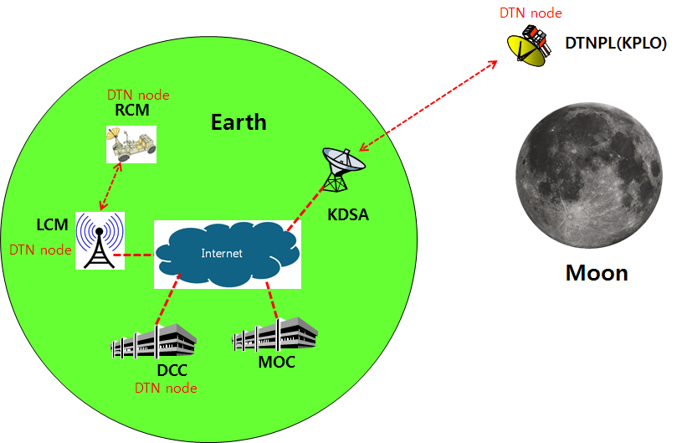
Figure 2.1 DTN test configuration in the first phase

Communication Nodes
Many communication nodes are needed for the DTN operation. Some of communication nodes in the network are DTN nodes whereas otherwise nodes are non-DTN nodes. The function of communication nodes used in the DTN operation is as follows.

DTN nodes
- DCC is a ground DTN node which monitor and controls DTN nodes. DCC send commands to DTN nodes such as DTNPL, LCM and RCM. It also receives telemetries or acquired data from some DTN nodes such as RCM or LCM.
- DTNPL is a DTN node mounted on the KPLO. DTNPL can be operated as a DTN end point. And it also can be operated as relay nodes which relay DTN data between DCC and RCM or LCM.
- LCM is a ground DTN node. LCM relays DTN data between MOC and RCM.
- RCM is a ground DTN node and a DTN end point. The commands sent by the DCC is terminated at the RCM and the RCM returns telemetry or data to DCC through KPLO.

Non-DTN nodes
- MOC is a non-DTN node. MOC monitors and controls KPLO and payloads. MOC also receives and processes data generated from the payloads and transfers to each payload control center.
- KDSA is a ground station for deep space communication. KDSA will have a big size of antenna and RF equipment for space link interface. KDSA also has network equipment for terrestrial communication interface such as SLE link. KDSA is a non-DTN node.

Operations and Maintenance Manual
The DTN payload (DTNPL) shall have interface with KPLO for the operational power supply and for the communications. The following figure shows DTN payload interface diagram with KPLO.

Figure 3-1 Interface diagram of DTN payload

There are four kinds of interface types between DTNPL and KPLO. Each interface types are described as following.
- TM/TC (bi-level): One bi-level TC and one bi-level TM for DTNPL emergency operation.
- Bi-level TC: System reset command in the emergence condition
- Bi-level TM: Telemetry showing that DTNPL is in alive
- TM/TC (UART): Serial communication channel for TM/TC communication with KPLO OBC
- Data downlink (USRT): Serial data downlink channel to KPLO PDHU
- Power: Operation DC power +28V from the KPLO PCDU

The detailed electrical configuration of DTNPL is shown below figure.

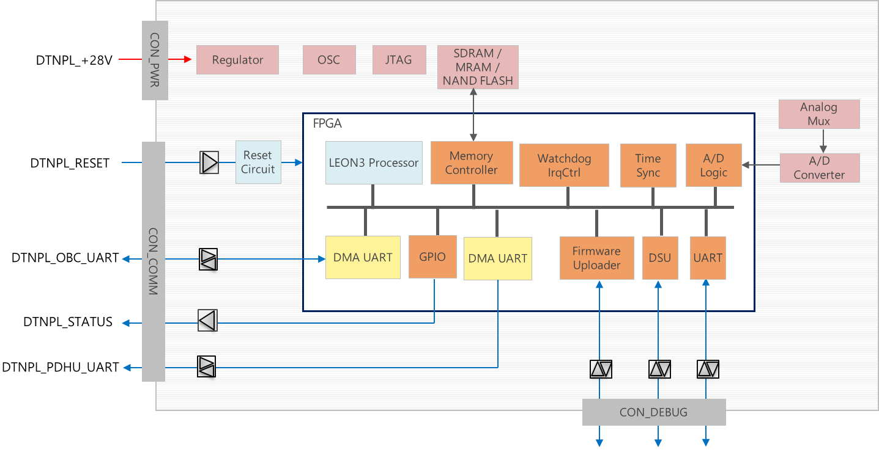
Figure 3-2 Electrical block diagram of DTN payload

Communication Protocols
There are two kinds of communication protocols between DTNPL and KPLO as following.

Table 4-1 DTNPL Protocols
 | TM/TC Protocol | Datalink Protocol
Communication link | DTNPL ↔ OBC(KPLO) | DTNPL → PDHU(KPLO)
Application | TM/TC communication (OBC ↔ DTNPL)  File transfer using DTN (OBC → DTNPL) | File transfer using DTN (DTNPL → PDHU)  Video streaming using DTN (DTNPL → PDHU)
ACK | Echo back | None
Single/Multiple | Single packet: TM/TC  Multiple packets: File transfer | Multiple packets

TM/TC Protocols

UART Protocol
DMA UART will be used for the communication between DTNPL and KPLO OBC.
- Baud rate: 115.2 kbps
- None-Parity, 8 Data bit and 1 Start/Stop bit (N, 8, 1)
- ACK method: Echo back
- ID pattern: 0xAA

Packet Format
The maximum packet size is 70 byte. The TM/TC packet is consists of following fields.

Figure 4-1 TM/TC packet structure

The packet fields are defined in following table.

Table 4-2 TM/TC Packet Format
Field name | Size | Description | Value
Sync | 1 byte | Sync pattern for UART communication | 0xAA
Length | 1 byte | Length of data field (byte) | 2(0x02) ~ 67(0x43)
Command | 1 byte | Type (1 bit) | SBC(0), DTN(1)
Command | 1 byte | Response Channel (1 bit) | OBC(0), PDHU(1)
Command | 1 byte | Single/Multiple (1 bits) | Single packet(0)  Multiple packet(1)
Command | 1 byte | Write/Read (1 bits) | Write(0), Read(1)
Command | 1 byte | Command number (4 bits) | 0(0x00) ~ 15(0x0F)
Data | Variable | Data (max. 67 byte) | Refer to Table 4-3

Table 4-3 Data Field Format
Sub-field name | Size | Description | Value
Packet No | 2 byte | Single packet  Multiple packets serial number | 0  0(0x00) ~ 65535(0xFFFF)
Data | 65 byte | Payload data

TM/TC Data Structure
TM/TC data structure is as following.

Table 4-4 TM/TC data structure
Type | Name | Sync | Length | Command | Data
 |  |  |  |  | Packet No | Payload Data
SBC TC | Echo test | 0xAA | 0x02 + Payload Data length | 0x00 | 0x0000 | variable
SBC TC | SW initialize | 0xAA | 0x02 | 0x01 | 0x0000 | None
SBC TC | Time setting | 0xAA | 0x08 | 0x02 | 0x0000 | OBT  - week since 2000-01-01 12:00:00 UTC (2 byte)  - octant second (4 byte)
SBC TC | SOH request | 0xAA | 0x02 | 0x13 | 0x0000 | None
SBC TC | Script (ionstart) | 0xAA | 0x0E | 0x04 | 0x0000 | Script command (12 byte)
SBC TC | Script (killm) | 0xAA | 0x09 | 0x05 | 0x0000 | Script command (7 byte)
SBC TC | DCC data | 0xAA | 0x02~0x43 | 0x06 | 0x0000 ~ 0xFFFF | DCC TC/data (0 ~ 65 byte)
SBC TC | RFU1 | 0xAA | 0x2A | 0x07 | 0x0000 | Reserved (40 byte)
SBC TC | RFU2 | 0xAA | 0x2A | 0x08 | 0x0000 | Reserved (40 byte)
SBC TC | RFU3 | 0xAA | 0x2A | 0x09 | 0x0000 | Reserved (40 byte)
SBC TC | RFU4 | 0xAA | 0x2A | 0x0A | 0x0000 | Reserved (40 byte)
SBC TC | RFU5 | 0xAA | 0x2A | 0x0B | 0x0000 | Reserved (40 byte)
SBC TM | SOH data | 0xAA | 0x3C | 0x14 | 0x0000 | SOH data (58 byte)
SBC TM | RFU1 | 0xAA | 0x06 | 0x15 | 0x0000 | Reserved (4 byte)
SBC TM | RFU2 | 0xAA | 0x06 | 0x16 | 0x0000 | Reserved (4 byte)
SBC TM | RFU3 | 0xAA | 0x06 | 0x17 | 0x0000 | Reserved (4 byte)
SBC TM | RFU4 | 0xAA | 0x06 | 0x18 | 0x0000 | Reserved (4 byte)
SBC TM | RFU5 | 0xAA | 0x06 | 0x19 | 0x0000 | Reserved (4 byte)

Datalink Protocol
Datalink protocol is used for payload data transfer from DTNPL to PDHU. USRT will be used for the datalink protocol and characteristics are as following.

Datalink protocol for downlink
The downlink datalink packet structure can be expressed logically as following.
- Packet structure = VN + Type + SHF + APID + SF + PSC + PL + SP + User data + CRC
  - Where; VN: Version Number, SHF: Secondary Header Flag, APID: Application Process ID, SF: Sequence Flags, PSC: Packet Sequence Count, PL: Packet Length, SP: Sync Pattern, CRC: Cyclic Redundancy Check
The downlink datalink packet structure can be expressed as following figure.

Figure 4-2 Downlink datalink packet structure

The datalink packet structure is as following.
Table 4-5 Datalink packet structure
Field name | Size (bit) | Description | Comments
VN | 3 | 000b | Version 1
Type | 1 | 0b | Telemetry
SHF | 1 | 1b
APID | 11 | 11 bits
SF | 2 | 11b (standalone) or combination of 01b / 00b / 10b (first / continue / last)
PSC | 14 | Modulo-16384, 0 ~ 16383 | The sequential binary count of each packet
PL | 16 | (Length of User Data Field) - 1
SP | 32 | 0x352EF853
User Data Field | Variable | Max 65536 Octets. Refer to Table 4-6.
CRC | 16 | CRC-16-CCITT (Polynomial: x¹⁶+x¹²+x⁵+1)

The contents of User Data Field are as following.

Table 4-6 Contents of User Data Field
Sub-field | Size (bit) | Description | Comments
Sync | 8 | Sync pattern for USRT communication
Length | 8 | Refer to Table 4-2 and Table 4-3
Command | 8 | Refer to Table 4-2 and Table 4-3
Packet No. | 16 | Refer to Table 4-2 and Table 4-3
Data | Variable | Variable. Max 65531 Octets. | DTN TM  - AMS message  - CFDP file data

Datalink Data Structure
Datalink data structure is as following.

Table 4-7 First frame datalink structure
VN | Type | SHF | APID | SF | PSC | PL | SP | User Data Field | CRC
000b | 0b | 1b | xxx xxxx xxxxb | 01b | 00 0000 0000 0000b | xxxx xxxx …. | 0x352EF853 | Variable | [TBD]

Table 4-8 Last frame datalink structure
VN | Type | SHF | APID | SF | PSC | PL | SP | User Data Field | CRC
000b | 0b | 1b | xxx xxxx xxxxb | 10b | xx xxxx xxxx xxxxb | xxxx xxxx …. | 0x352EF853 | Variable | [TBD]

TM/TC Lists

Command Lists
There are two kinds of command types in the DTNPL as following.
- SBC commands: DTNPL control
- DTN commands: ION-DTN control. They are transmitted by AMS from DCC to DTNPL.
The DTNPL command lists are shown in following table.

Table 4-9 DTNPL Command Lists
Type | TC name | Description
SBC | Echo test | UART communication checking
SBC | SW initialize | Initialize system
SBC | Time setting | Set On Board Time
SBC | SOH request | Request SOH TM
SBC | RFU_1 | Reserved for future use
SBC | RFU_2 | Reserved for future use
SBC | RFU_3 | Reserved for future use
SBC | RFU_4 | Reserved for future use
SBC | RFU_5 | Reserved for future use
DTN | Script (ion start) | ION Start
DTN | Script (killm) | Close all process
DTN | DCC data | AMS TC / CFDP file data transfer

Telemetry Lists
There are two kinds of telemetry types as following.
- SBC telemetries: The SOH (State Of Health) of DTN payload to be reported to the KPLO FSW to monitor DTNPL health condition.
- DTN telemetries: Response to DTN command. They are transmitted by AMS from DTNPL to DCC.
The detailed telemetry lists are shown in below.

Table 4-10 DTNPL Telemetry Lists
Type | TM name | Description | Size  (byte) | Start time  (sec.) | Update interval | Transmit interval to FSW
SBC | SOH Data | temp_board (Board temperature) | 4 | Auto count after DTNPL power ON | <1 sec. | After receiving SOH request (32 sec).
SBC | SOH Data | temp_fpga (FPGA temperature) | 4 | Auto count after DTNPL power ON | <1 sec. | After receiving SOH request (32 sec).
SBC | SOH Data | volt_28 (28.0V input voltage level) | 2 | Auto count after DTNPL power ON | <1 sec. | After receiving SOH request (32 sec).
SBC | SOH Data | volt_3.3 (3.3V voltage level) | 2 | Auto count after DTNPL power ON | <1 sec. | After receiving SOH request (32 sec).
SBC | SOH Data | volt_1.0 (1.0V voltage level) | 2 | Auto count after DTNPL power ON | <1 sec. | After receiving SOH request (32 sec).
SBC | SOH Data | curr_28 (28.0V input current level) | 2 | Auto count after DTNPL power ON | <1 sec. | After receiving SOH request (32 sec).
SBC | SOH Data | time (Current DTNPL time) | 6 | Auto count after DTNPL power ON | 1 sec. | After receiving SOH request (32 sec).
SBC | SOH Data | run_time (Time(second) count after DTNPL power on) | 4 | Auto count after DTNPL power ON | 1 sec. | After receiving SOH request (32 sec).
SBC | SOH Data | fpga_ver (SBC FPGA version) | 4 | Auto count after DTNPL power ON | Fixed | After receiving SOH request (32 sec).
SBC | SOH Data | fw_ver (SBC firmware version) | 4 | Auto count after DTNPL power ON | Fixed | After receiving SOH request (32 sec).
SBC | SOH Data | edac (EDAC count) | 4 | Auto count after DTNPL power ON | Event occurred | After receiving SOH request (32 sec).
SBC | SOH Data | tmtc_rx_pkt_cnt (OBC→DTNPL received packet count) | 4 | Auto count after DTNPL power ON | When packet received | After receiving SOH request (32 sec).
SBC | SOH Data | tmtc_tx_pkt_cnt (DTNPL→OBC send packet count) | 4 | Auto count after DTNPL power ON | When packet sent | After receiving SOH request (32 sec).
SBC | SOH Data | downlink_pkt_cnt (DTNPL→PDHU send packet count) | 4 | Auto count after DTNPL power ON | When packet sent | After receiving SOH request (32 sec).
SBC | SOH Data | dtn_state (ION start/stop state) | 4 | Auto count after DTNPL power ON | 1 sec. | After receiving SOH request (32 sec).
SBC | SOH Data | ion_ver (ION version) | 4 | Auto count after DTNPL power ON | Fixed | After receiving SOH request (32 sec).
SBC | RFU_1 | Reserved for future use | 4 | - | [TBD] | [TBD]
SBC | RFU_2 | Reserved for future use | 4 | - | [TBD] | [TBD]
SBC | RFU_3 | Reserved for future use | 4 | - | [TBD] | [TBD]
SBC | RFU_4 | Reserved for future use | 4 | - | [TBD] | [TBD]
SBC | RFU_5 | Reserved for future use | 4 | - | [TBD] | [TBD]
DTN | [TBD] | [TBD] | - | - | - | -

